Assignment 4

Q1. Configure DHCP Services with a Server.
- Create one Server-PT, one Cisco 2960 switch, and five PCs in Cisco Packet Tracer.
- Connect the server and all PCs to the switch using Copper Straight-Through cables.
- Click Server0 → Desktop → IP Configuration and assign the static IP address 192.168.1.2, subnet mask 255.255.255.0, and default gateway 192.168.1.1.
- Click Server0 → Services → DHCP, turn the DHCP service On, and configure the following settings:
- Pool Name: LAN
- Default Gateway: 192.168.1.1
- DNS Server: 8.8.8.8
- Start IP Address: 192.168.1.10
- Subnet Mask: 255.255.255.0
- Maximum Number of Users: 50
- Click Add or Save to create the DHCP pool.
- For each PC, open Desktop → IP Configuration and select DHCP to obtain an IP address automatically.
- Switch to Simulation Mode and filter for DHCP packets to observe the four stages of the DORA process.

DHCP DORA Process
- Discover: The PC broadcasts a DHCP Discover packet to find a DHCP server.
- Offer: The server offers an available IP address to the PC.
- Request: The PC requests the offered IP address.
- Acknowledge: The server confirms the assignment, and the PC receives its network configuration.

Discover Packet
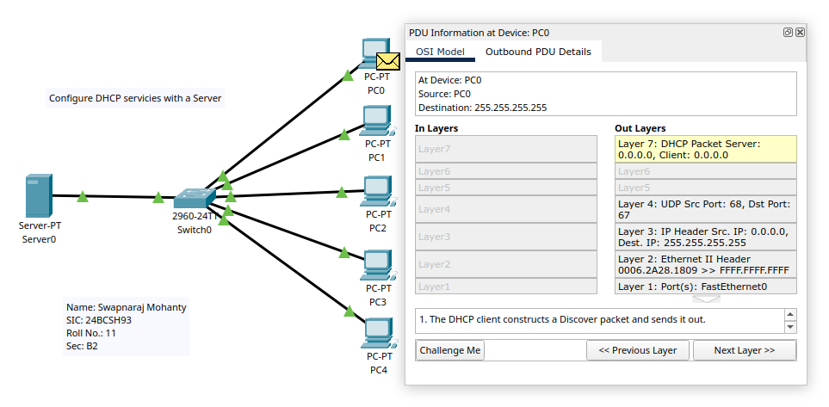

Offer Packet:
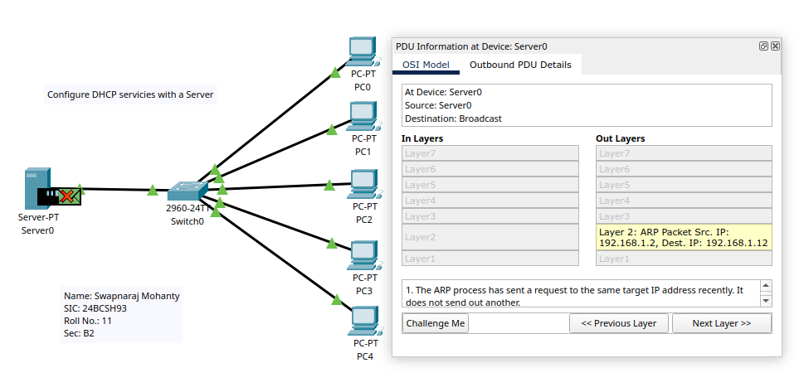

Request Packet:
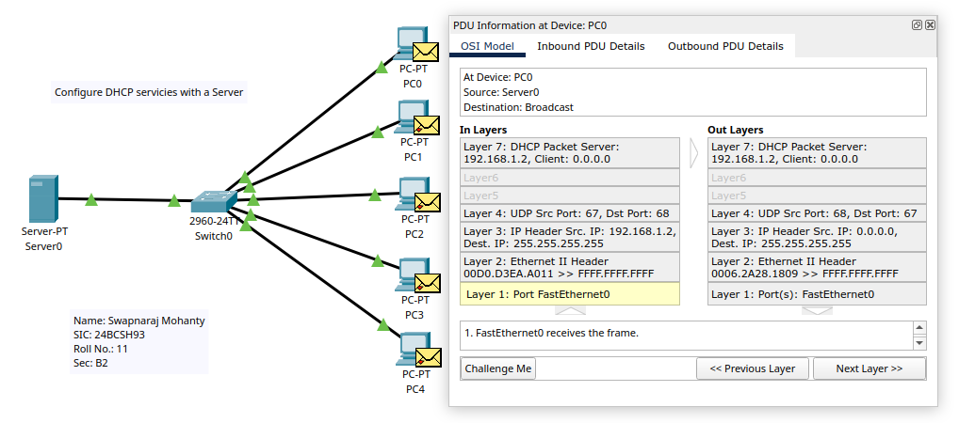

Acknowledge Packet:
